**Course 3 – Sprint 5 – Assessment 1 – Predict the output**

# Predict the output of the following code: *

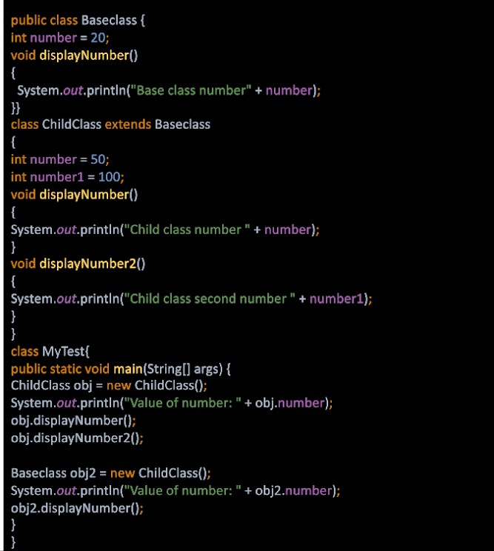

1. **Which of the following statements are false for method overriding in java?** *

*Mark only one oval.*

### This is also called dynamic polymorphism or runtime polymorphism. Overriding occurs between the methods in the same class.

Overriding occurs between the superclass and subclass.

### Overriding methods have the same signature, i.e., the same name and method arguments.

In method overriding, the method to call is determined at runtime based on the object type.

# Fix the compile time error in the code and also explain why the error is *

**coming?**

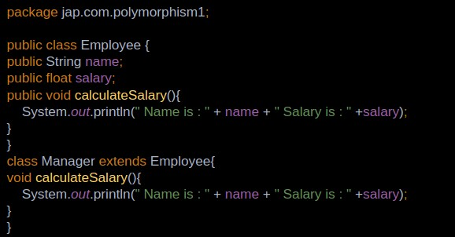

# Write the code for the comments provided and predict the output as well *

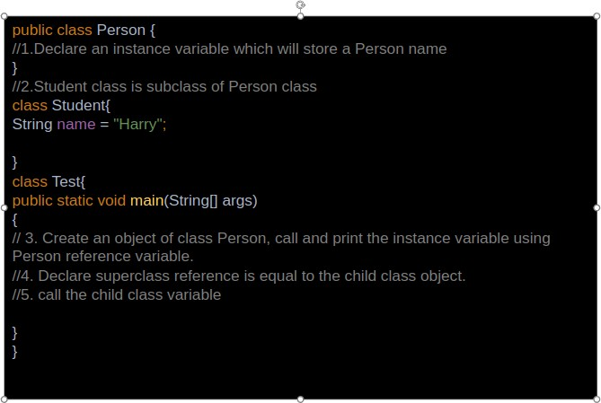

1. **Predict the output for the following code** *

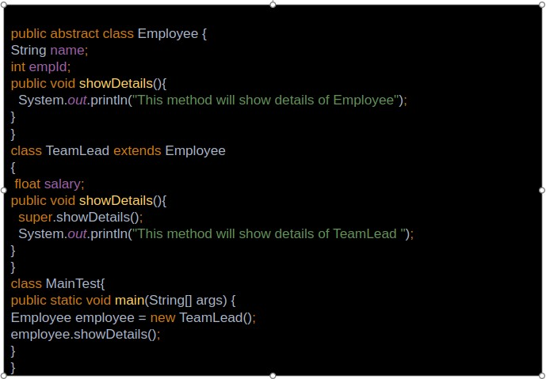

# Predict the output of the below code.

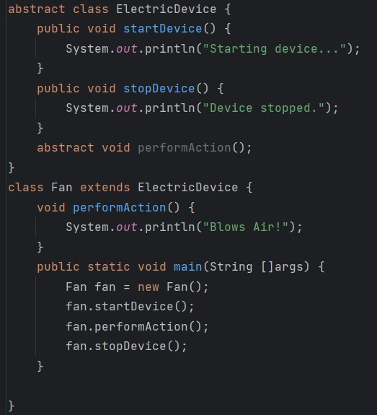

1. **Fix the compile time errors in the below code**

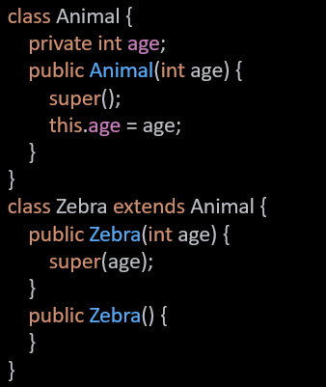

# Will the below code compile without errors ? Give reasons

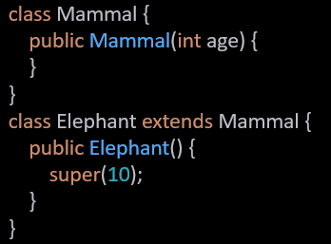

1. **Predict the output of the below code.**

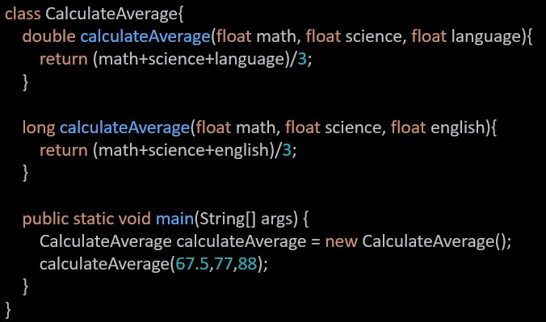

# Predict the output of the below code. Give reasons

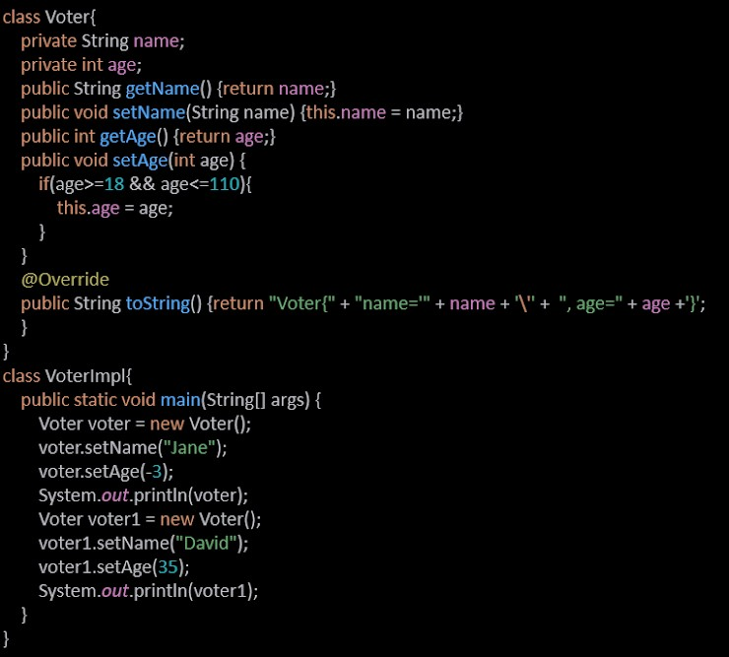

1. **Following code is giving compile time error, fix the code and also explain why it is giving compile time error**

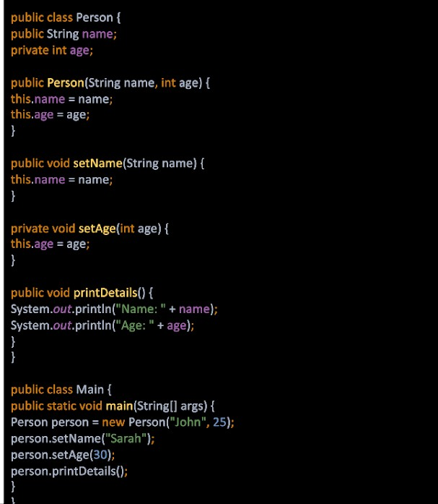

1. **Predict the output of the below code. Give reasons**

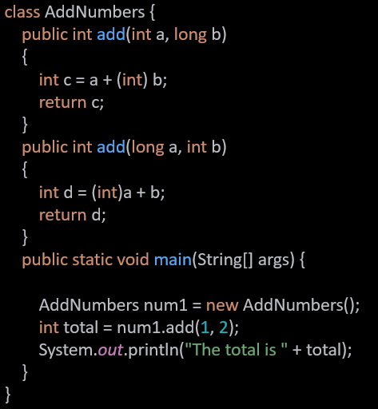

1. **Predict the output of the below code.**

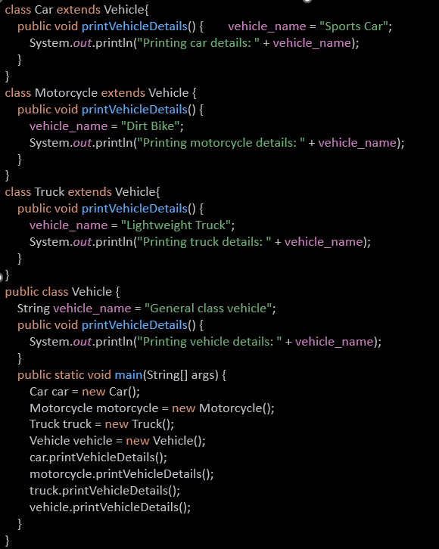

1. **Predict the output of the below code. Give reasons**

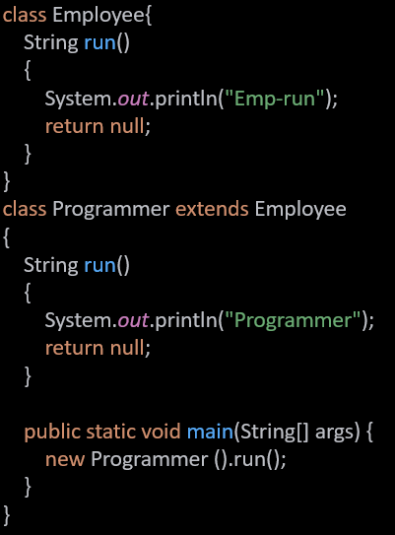

1. **Choose the correct option and give reasons**

## The code exhibits polymorphism with classes

* 1. The code exhibits polymorphism with methods

## The code does not exhibit polymorphism

* 1. The code exhibits polymorphism with classes and interfaces

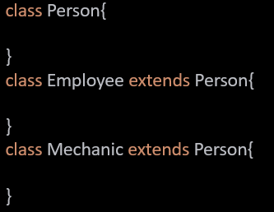

1. **Predict the output of the below code.**

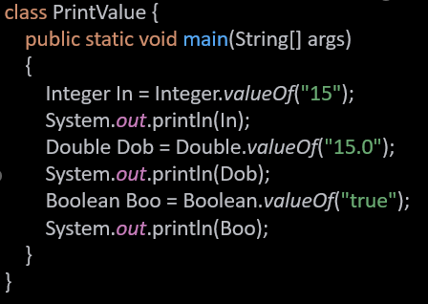

1. **Predict the output of the below code.**

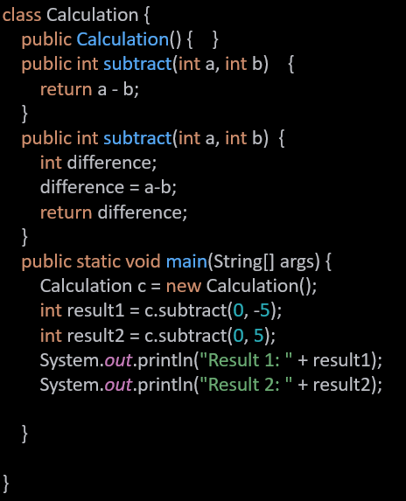

1. **Predict the output of the below code**

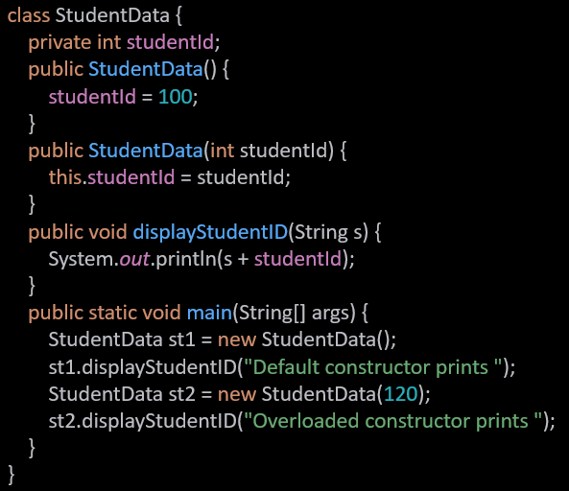

# Following code is giving compile time error, fix the code and also explain *

**why it is giving compile time error**

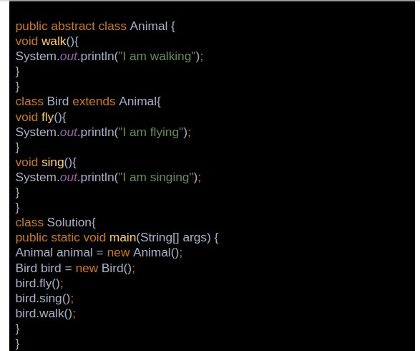

# Identify and fix the error in the below code

